ORDER MAINTENANCE

Refer DN: 0020008048 , Wavekey = 0000057655

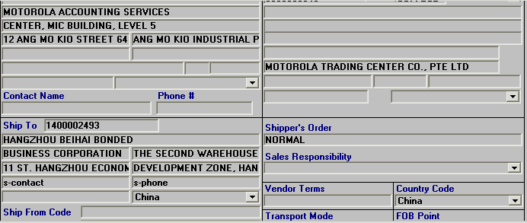
Ship to company
When not enough column from
Ship To’ BOX

Ship to contact
Ship to phone

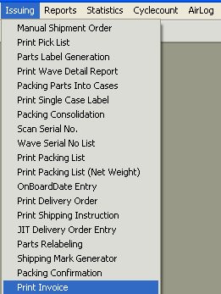

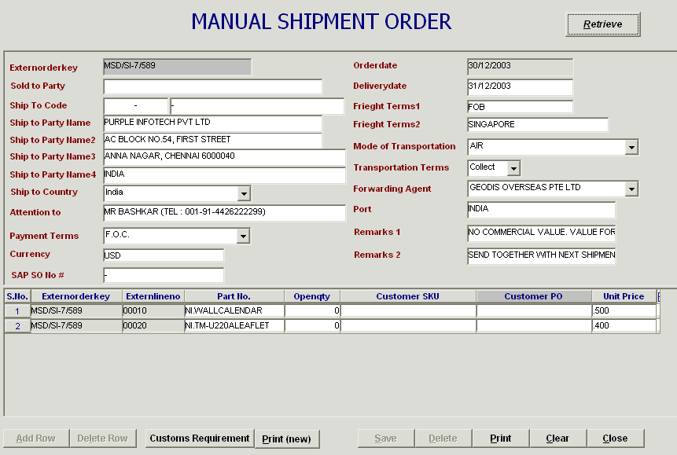
New invoice printing
Unit price auto extract from Exceed->SKU Maintenance

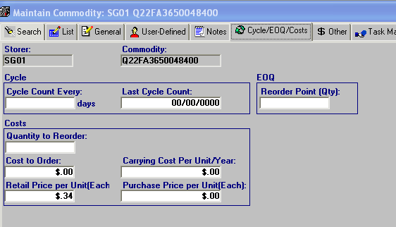
Unit Price

